**Lab 1.2**

Sơ đồ class:

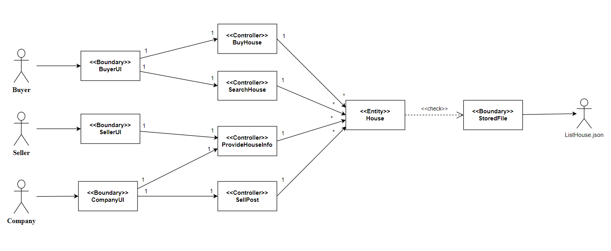

Sequence Diagram:

